*vivo mobile*

vivo y02t

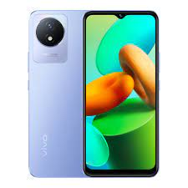

Product Color. Y02t. Cosmic Grey · Body. Y02t. Dimensions. **163.99 × 75.63 × 8.49 mm** · Price. Rs. 29,999 (4GB+64GB) Rs. 33,999 (4GB+128GB) · Basic. Color. Orchid

**PRICE / 29,000 PRK**